User’s
Manual

Step 1 install for Widows
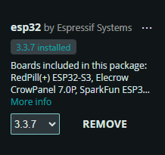
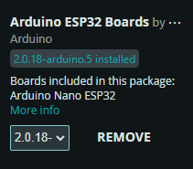
https://downloads.arduino.cc/arduino-ide/nightly/arduino-ide_nightly-latest_Windows_64bit.zip
Available on Linux and MacOS
https://www.arduino.cc/en/software/
Step 2 Go To Board Manager and Search Esp32 Install this two
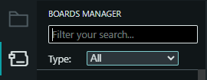

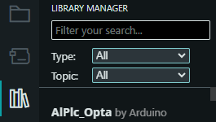
Step 3 After That Under the Board Manager Go to Library Manager Search this all and install all

- Universal Telegram Bot by Brian Lough
- Adafruit GFX Library by Adafruit
- Adafruit SSD1306 by Adafruit
- SparkFun MAX3010x Sensor Library

If there is problem install this:https://www.silabs.com/software-and-tools/usb-to-uart-bridge-vcp-drivers?tab=downloads

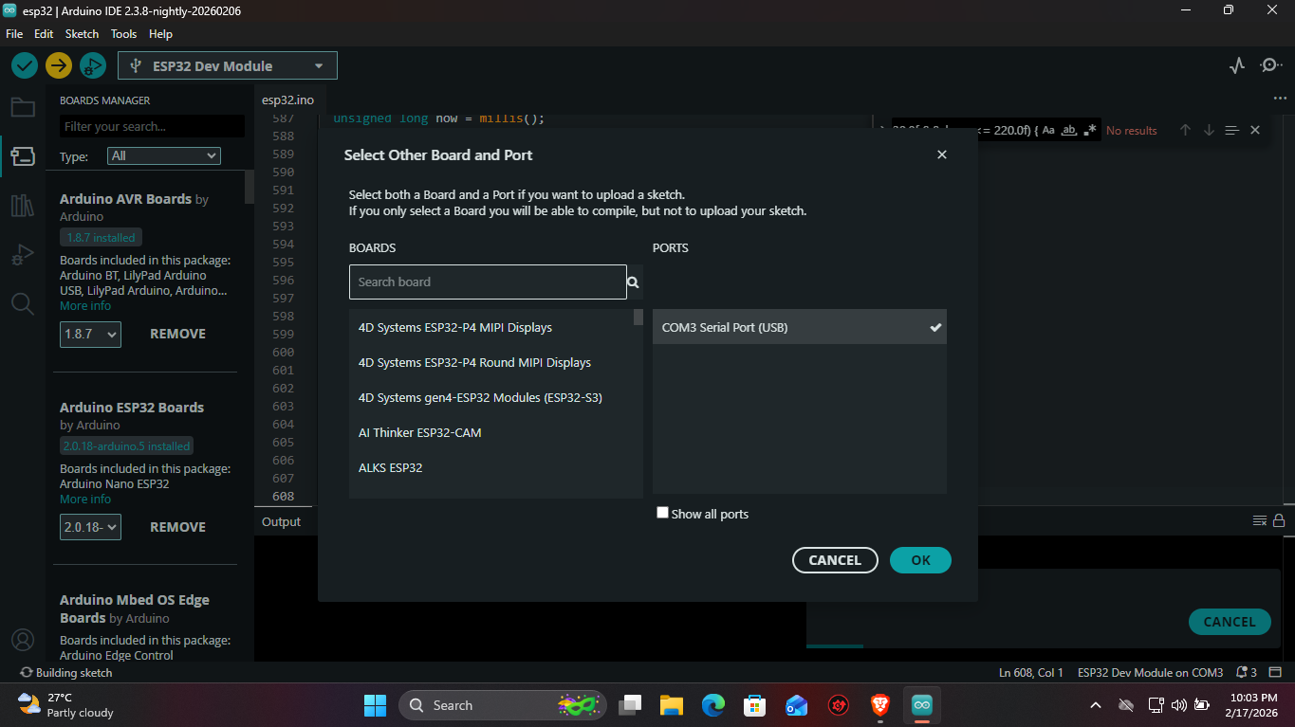
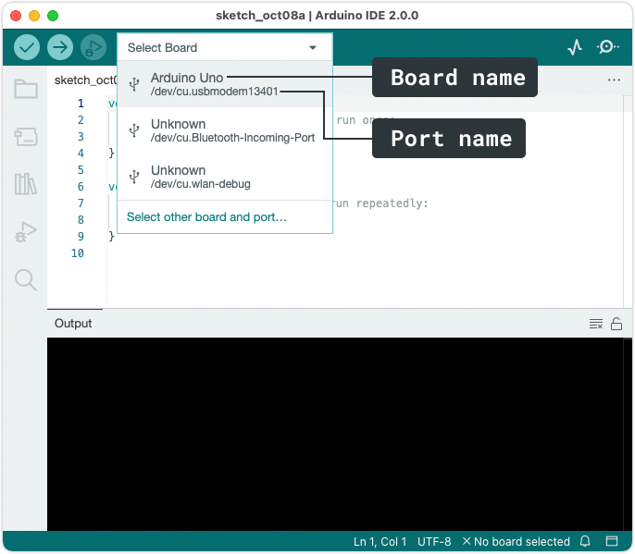
Step 4 Plug the Esp 32 in Usb Port And Click the Select other Board and port And Find The ESP 32 Dev Module In boards and Click ok
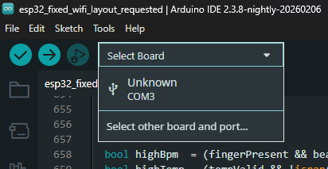

Step 5 Change The Telegram Details and Wifi Name and Wifi Password find this code and put the name and the password and Also Change the Chat id of the telegram dont remove the bot token to see the user id click this link https://t.me/userid_bot then type /start then click My Info then and Copy the Id In the Chat ID
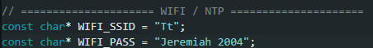
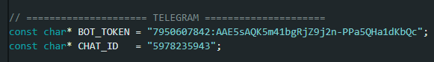
Step 6 Click the Upload Icon in the top then wait to Transfer in Esp32
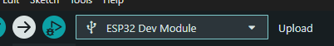

Step 7 Wait for the Compilation

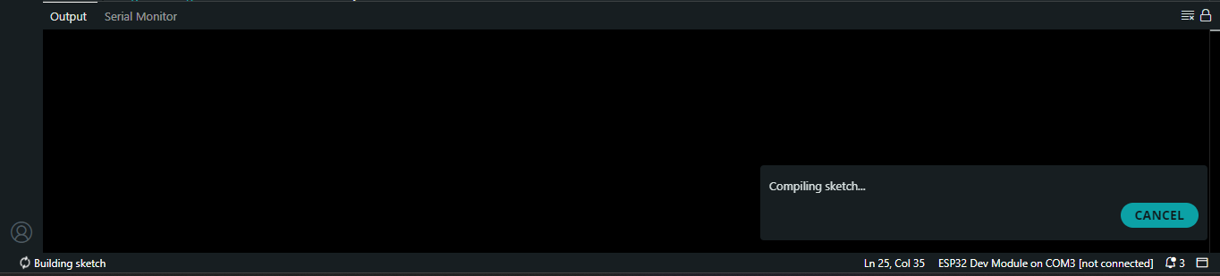

Schematics
